Write a C++ program that will create an array of type double numbers with a given number of elements. Use the number of elements const int size = 10 for demonstration purposes, but write the program where the size of the array can be changed by changing the value of one constant. Fill the array with random type double numbers between 0 and 100 using the expression rand()%100 to generate the numbers. Write the program to present options to the user as a menu and perform the following operations:
1. Create a new array with random elements.
2. Display the elements of the array.
3. Find and display the largest value in the array.
4. Find and display the smallest value in the array.
5. Sort the array in descending order and display the array.
6. Find and display the mean value.
7. Find and display the median value.
8. Find and display the variance.
9. End
Each operation shall be written as an individual function. Pass the array address to the functions and the size of the array.
Document the program with a document with the following sections:

A. A written description of the purpose of the program and a description of the program structure.
This program allows users to create and manipulate an array of random double values. Users can generate an array, display its contents, find the maximum and minimum values, sort it in descending order, and compute statistical measures such as mean, median, and variance. Each operation is implemented as a separate function, with the array and its size passed as arguments. The program features a menu-driven interface, enabling users to interactively select operations until they choose to exit.

B. A diagram that illustrates the structure of the program.
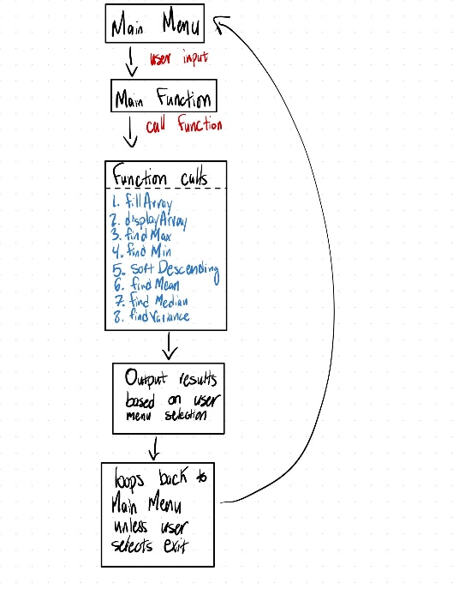

C. The code listing.
//ECE 2305 - Programming Project 05

#include <iostream>
#include <cstdlib>
#include <ctime>
#include <algorithm>
#include <cmath>

using namespace std;

const int SIZE = 10;

void fillArray(double arr[], int size) { for (int i = 0; i < size; i++) arr[i] = rand() % 100; }
void displayArray(const double arr[], int size) { for (int i = 0; i < size; i++) cout << arr[i] << " "; cout << "\n"; }
double findMax(const double arr[], int size) { return *max_element(arr, arr + size); }
double findMin(const double arr[], int size) { return *min_element(arr, arr + size); }
void sortDescending(double arr[], int size) { sort(arr, arr + size, greater<double>()); }
double findMean(const double arr[], int size) { double sum = 0; for (int i = 0; i < size; i++) sum += arr[i]; return sum / size; }
double findMedian(const double arr[], int size) { double* tempArr = new double[size]; copy(arr, arr + size, tempArr); sort(tempArr, tempArr + size); double median = size % 2 == 0 ? (tempArr[size / 2 - 1] + tempArr[size / 2]) / 2.0 : tempArr[size / 2]; delete[] tempArr; return median; }
double findVariance(const double arr[], int size, double mean) { double sum = 0; for (int i = 0; i < size; i++) sum += pow(arr[i] - mean, 2); return sum / size; }

int main() {
srand(time(0));
double arr[SIZE];
int choice;
while (true) {
cout << "\nMenu:\n1. New array\n2. Display\n3. Max\n4. Min\n5. Sort\n6. Mean\n7. Median\n8. Variance\n9. Exit\nChoice: ";
cin >> choice;
if (choice == 9) break;
switch (choice) {
case 1: fillArray(arr, SIZE); break;
case 2: displayArray(arr, SIZE); break;
case 3: cout << "Max: " << findMax(arr, SIZE) << "\n"; break;
case 4: cout << "Min: " << findMin(arr, SIZE) << "\n"; break;
case 5: sortDescending(arr, SIZE); displayArray(arr, SIZE); break;
case 6: cout << "Mean: " << findMean(arr, SIZE) << "\n"; break;
case 7: cout << "Median: " << findMedian(arr, SIZE) << "\n"; break;
case 8: cout << "Variance: " << findVariance(arr, SIZE, findMean(arr, SIZE)) << "\n"; break;
default: cout << "Invalid choice.\n";
}
system("pause");
}
return 0;
system("pause");
}

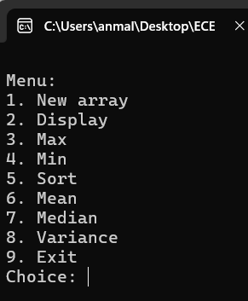
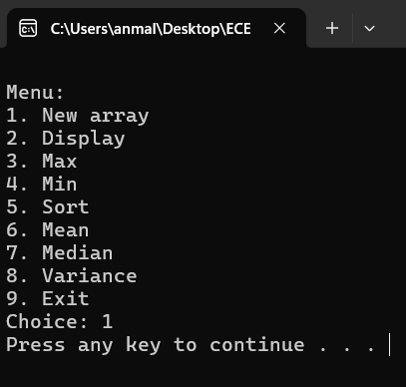
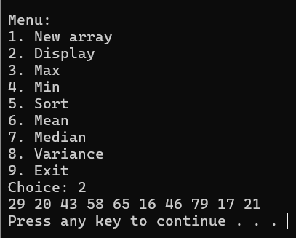
D. Screen shots showing the results of each operation.
